Data Visualizations of Places of Worship in the USA

Halleigh Kelchen  
halleighlkelchen@lewisu.edu  
DATA-53000, Spring 2024

Data Visualization Lewis University

# Introduction

The religious landscape in the United States continues to fluctuate. About seventy percent of Americans identify as Christian and nearly twenty-three percent of Americans remain religiously unaffiliated [1]. However, there are more than 45,000 denominations globally that are considered Christian [1]. This study aims to examine the top denominations in the United States and the religious makeup of the United States in recent years using geospatial data from 2019. This report uses multiple data visualizations to identify potential relationships between the different attributes and the number of places of worship in the United States.

# Data Description

As described in the above section, the dataset used for this study is from a public domain forum compiled in 2019 of places of worship in the United States [2]. This dataset includes 49,328 places of worship and 15 attributes [2]. Data visualization will be used to understand the geospatial relationship of this large dataset. This dataset has been used for a variety of exploratory studies by other students and people in the data science industry to examine religion in the United States. The dataset contains various information about each place of worship including the location, denomination, type, and religious subtype it falls into. Table I. below identifies the 15 different attributes and the target variable which is the number of places of worship.

1. Data Attributes

| **Attribute** | **Type** | **Example Value** | **Description** |
| --- | --- | --- | --- |
| Name | Categorical | Mahajereen Mosque | Name of the place of worship |
| Telephone | Ordinal | 916-452-7132 | Phone number of the place of worship |
| Address | Categorical | 5770 Carlson Dr | Address of the place of worship |
| ID | Ordinal | 10438385 | Identifier assigned to the place of worship that is used as a count of places |
| City | Categorical | Hayward | City the place of worship is in |
| State | Categorical | CA | State the place of worship is in |
| Zip code | Categorical | 94549 | Zip code of the place of worship |
| County | Categorical | Sacramento | County the place of worship is in |
| Subtype | Categorical | Christian | The religious subgroup the denomination belongs to (ex. Christian) |
| Type | Categorical | Mosque | Type of place of worship (ex. Church, mosque, etc.) |
| Denomination | Categorical | LDS | Branch of religion the place of worship belongs to |
| Members | Numerical | 6 | The number of members registered to the place of worship |
| Attendance | Numerical | 500 | The amount of people who attend the place of worship |
| Protestant | Categorical | Y | Identifies whether the place of worship is protestant or not (Y or N) |
| Catholic | Categorical | Y | Identifies whether the place of worship is catholic or not (Y or N) |

# Methodology and results

The dataset was imported into Tableau and used to make multiple visualizations to help understand the geospatial relationships of the different attributes. In Fig. 1 below, a choropleth map was created to show the distribution of places of worship throughout the United States. Fig. 1 shows that California, Texas, and New York have the largest number of places of worship, compared to the other states. Fig. 1 also shows more places of worship in the southeast and northeast regions of the country compared to the western region of the country.

Fig. 1 Number of Places of Worship

A proportional symbol map by zip code is shown in Fig. 2 to show the distribution of the different subtypes of religion throughout the country. Fig. 2 shows that the Christian religion subtype is prominent throughout the country. Fig. 2 also shows the Buddhist subtype is also spread throughout the country, although in a noticeably smaller amount.

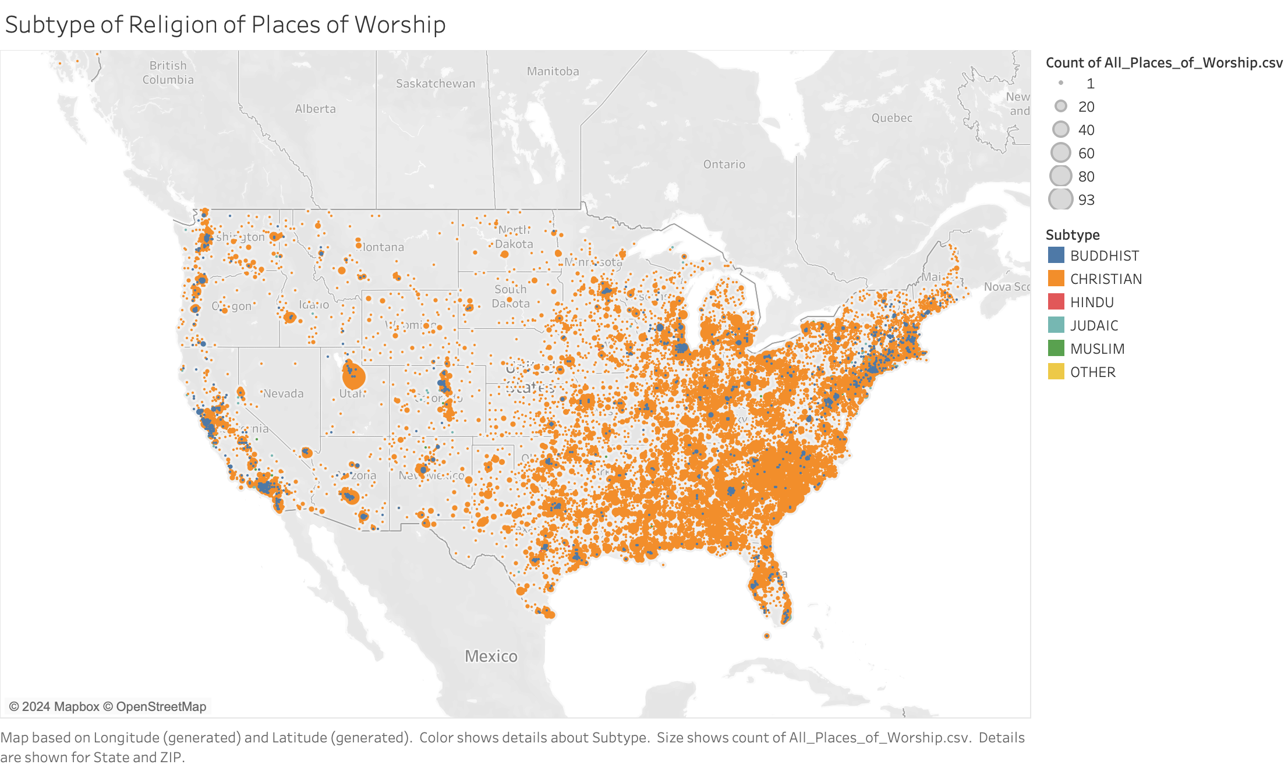

Fig. 2 Places of Worship by Religious Subtype

In Fig. 3, a proportional symbol map by state is also used to examine the top 8 denominations in the dataset and their distribution throughout the country. Fig. 3 shows that the American Baptist Church (ABC) in the northeast, Midwest, and western regions of the country, with the African Methodist Episcopal Zion Church (AMEZ) also spread throughout these regions in smaller amounts. The Church of Latter-day Saints (LDS) is shown to be concentrated in Idaho, Nevada, Utah, and Arizona. Fig. 3 also shows that Baptist (BAPT) Church and African Methodist Episcopal Church are prevalent in the south.

Fig. 3 Distribution of the Top 8 Religious Denominations in the U.S.

# Discussion

In Section III, different types of geospatial visualizations, such as choropleth maps and proportional symbol maps were used to visualize attributes of the data. Through these visualizations, the relationship and distribution of different variables were shown. The colors used in the different graphs were variations of the primary colors, chosen so that the visuals are easy to understand using information learned from design principles and color theory. Size was also used to create the different-sized circles in the proportional symbol maps. Using the information learned from the geospatial visualization content, proportional symbol maps were used to represent the raw data of the number of places of worship for both religious subtypes and denominations. A choropleth map was used to depict the distribution of the places of worship throughout the U.S. Since these are the only two types of geospatial visualizations available in tableau, these were the two types chosen for this study. Exploratory analysis of the dataset allowed for patterns in denomination, religious subtype, and the number of places of worship to be identified.

# Conclusions

This report used a dataset containing almost 50,000 places of worship in the United States to create different visualizations to examine the relationship between different attributes. With the visualizations, different conclusions were able to be drawn, such as the Christian religious subtype is still the most prominent religion in the United States. New patterns, such as the rise in Buddhism in the United States were also identified, along with patterns in denominations and number of places of worship by state.

##### References

[1] “*2020 PRRI Census of American religion*. PRRI. (2024, February 23). https://www.prri.org/research/2020-census-of-american-religion/

[2] Awram, C. (2020, May 27). *US places of worship Dataset*. data.world. https://data.world/awram/us-places-of-worship/discuss/us-places-of-worship/rxnwzguo